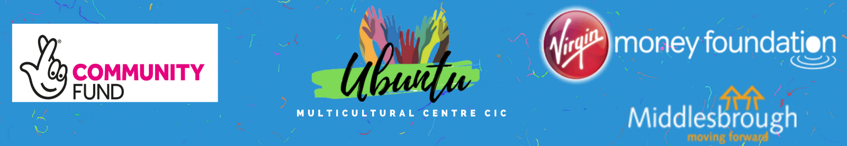

Inclusion & Diversity Form

We want to meet the aims and commitments set out in our Inclusion and Diversity policy. This includes not discriminating under the Equality Act 2010 and building an accurate picture of the make-up of the workforce in encouraging Inclusion and Diversity. We need your help and co-operation to enable it to do this but completing this form is voluntary. The information you provide will stay confidential, be stored securely and limited to only some colleagues in the organisation’s People Team department.

You can complete this form either online or printed out. If completing online, you can click the boxes to ‘tick’ them.

- What age group are you currently in? |  |  |  | - What is your religion or belief?
☐ 16-24  ☐ 25-29  ☐ 30-34  ☐ 35-39  ☐ 40-44  ☐ Prefer not to say | ☐ 45-49  ☐ 50-54  ☐ 55-59  ☐ 60-64  ☐ 65+ |  |  | ☐ No religion/belief  ☐ Buddhist  ☐ Hindu  ☐ Christian | ☐ Jewish  ☐ Muslim  ☐ Sikh  ☐ Prefer not to say
 |  |  |  | ☐ Other, please specify:
- What is your gender?  ☐ Male  ☐ Female  ☐ Prefer not to say  ☐ Other, please specify: |  |  |  | - What is your sexual orientation?
 |  |  |  | ☐ Heterosexual  ☐ Gay woman  ☐ Gay man |  | ☐ Bisexual  ☐ Prefer not to say
 |  |  |  | ☐ Other, please specify:
- What is your legal marital or civil partnership status?
☐ Never married and never registered a civil partnership
☐ Married  ☐ Divorced  ☐ Separated, but still legally married  ☐ Widowed  ☐ Prefer not to say |  | ☐ In a registered civil partnership  ☐ Formerly in a registered civil partnership which is now dissolved  ☐ Separated, but still in a registered civil partnership  ☐ Surviving partner from a registered civil partnership
- Do you have caring responsibilities? If yes, please tick all that apply:
☐ None
☐ Primary carer of a child/children (under 18)
☐ Primary carer of disabled child/children
☐ Primary carer of disabled adult (18 and over)
☐ Primary carer of older person
☐ Secondary carer (another person carries out the main caring role)
☐ Prefer not to say
- What is your ethnicity?
☐ Prefer not to say

Asian / Asian British  ☐ Indian  ☐ Pakistani  ☐ Bangladeshi  ☐ Chinese  ☐ Other, please specify:  Black / Black British  ☐ African  ☐ Caribbean  ☐ Other, please specify:  Other ethnic group  ☐ Arab  ☐ Other, please specify: |  |  | White  ☐ English  ☐ Welsh  ☐ Scottish  ☐ Northern Irish  ☐ Irish  ☐ British  ☐ Gypsy or Irish Traveller  ☐ Other, please specify:  Mixed / multiple ethnic groups  ☐ White and Black Caribbean  ☐ White and Black African  ☐ White and Asian  ☐ Other, please specify:
- Do you consider yourself to have a disability or health condition?
☐ Yes
☐ No
☐ Prefer not to say

If you answered ‘yes’, please indicate your disability or health condition(s):
☐ Vision (e.g. due to blindness or partial sight)
☐ Hearing (e.g. due to deafness or partial hearing)
☐ Mobility (e.g. such as difficulty walking short distances, climbing stairs, lifting and carrying objects)
☐ Learning or concentrating or remembering
☐ Mental Health
☐ Stamina or breathing difficulty
☐ Social or behavioural differences (e.g. due to neuro-diverse conditions such as Autism Spectrum or ADHD)
☐ Other, please specify:
☐ Prefer not to say

The information in this form is for monitoring purposes only. If you believe you need a ‘reasonable adjustment’ for a disability or health condition, then please discuss this with your manager, or the recruitment team if you are a job applicant.

RETURNING COMPLETED FORM

Please return completed forms along with your application form by the closing date via email to: info@ubuntumc.org.uk

You can also return via post to: Ubuntu Multicultural Centre, 49 Clifton Street, Middlesbrough, TS1 4BX

In accordance with our Inclusion and Diversity Policy, this form will be separated from your application form before shortlisting

We greatly appreciate your time completing this form

